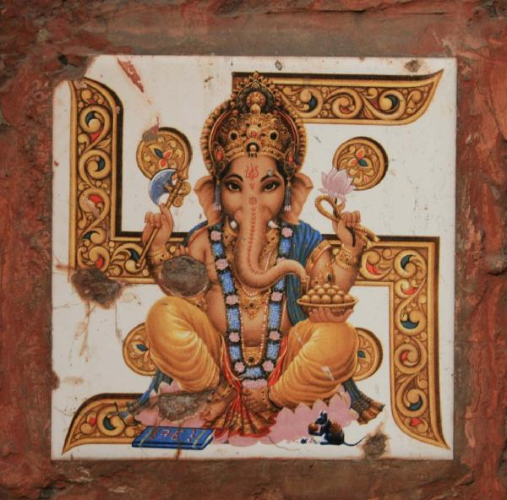
Ganesha Puja Meeting
All the soreness days gone. We are in the next step of starting our life at Anisha grange. Lets start celebrating and socializing with each other & share the real cheerful colors of life. We can have a fine start with Lord Sri ganesha Puje. To celebrate grand Sri Ganesha Puja all the residents of Anisha Grange are invited to assemble at AGRS Community Hall on 10th Sep 2007 (Sunday) at 11.00 AM .

Meeting Agenda
- Recommend the Cultural team associate (Block wise).
- Decide Puja plans & programs.
- Puja donation for AGRS Residents
- Puja donation for Non Residents.
- Puja Invitees
- Donation track Plan.
- Supplementary amusement agenda.

